Project Report Template

1. INTRODUCTION
   1. Overview

Performance and Efficiency of Radisson Hotels

1. Problem Definition &Design Thinking
   1. Empathy Map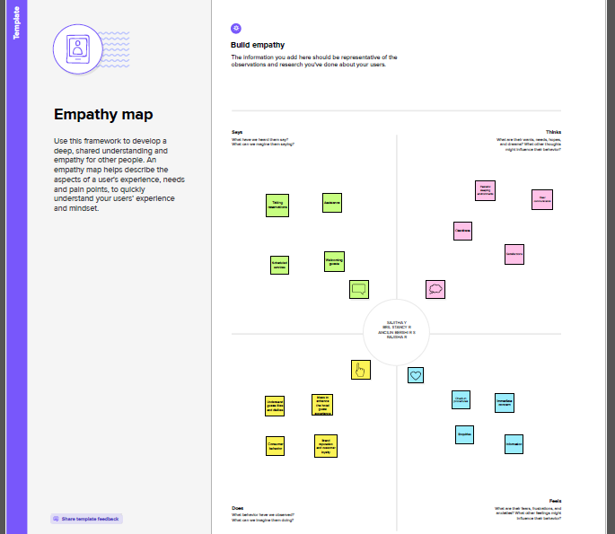
   2. Ideation & Brainstorming Map

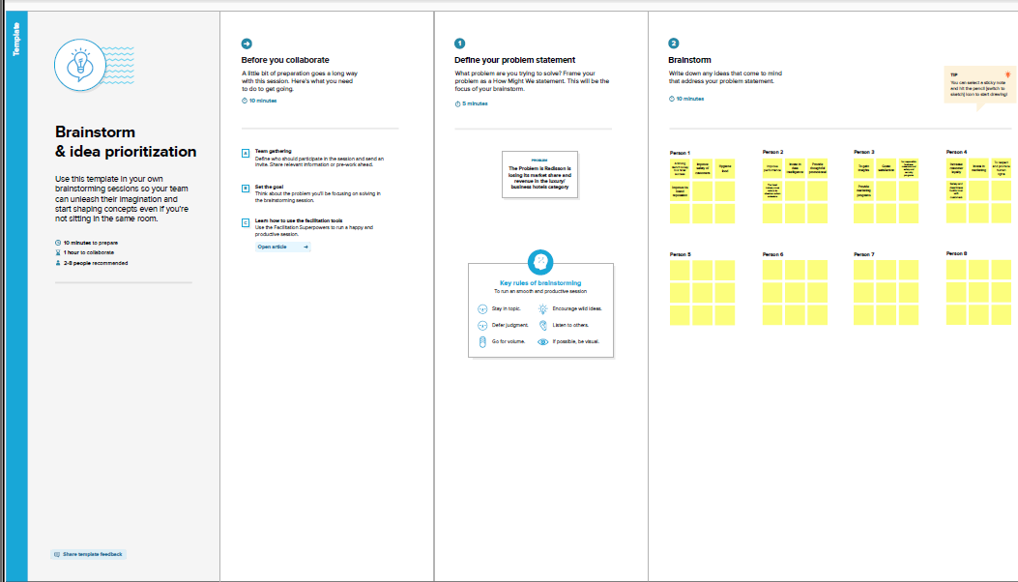

1. RESULT

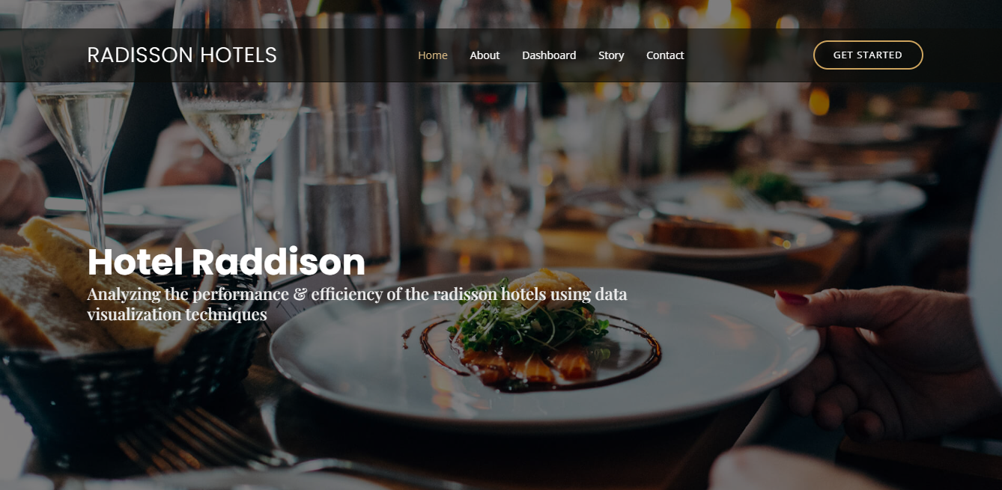

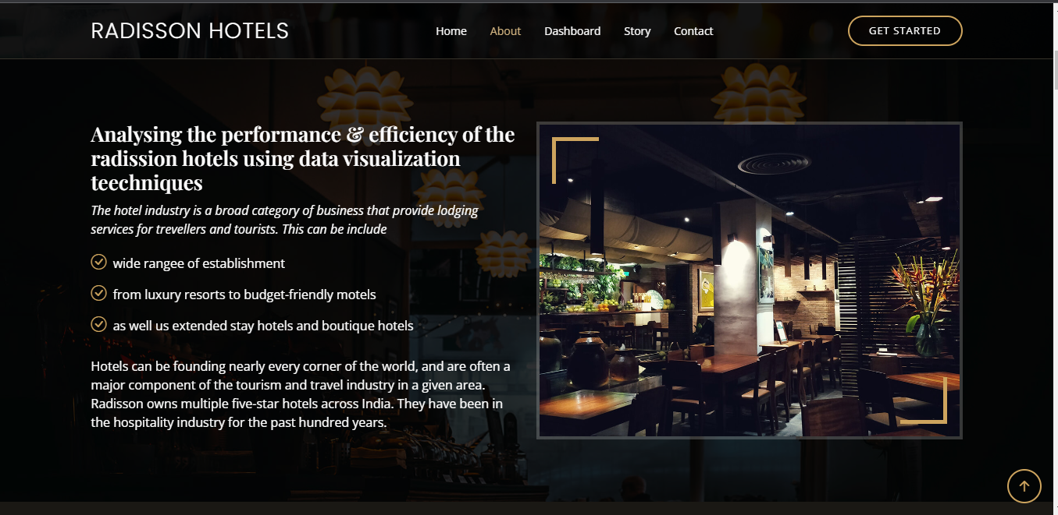

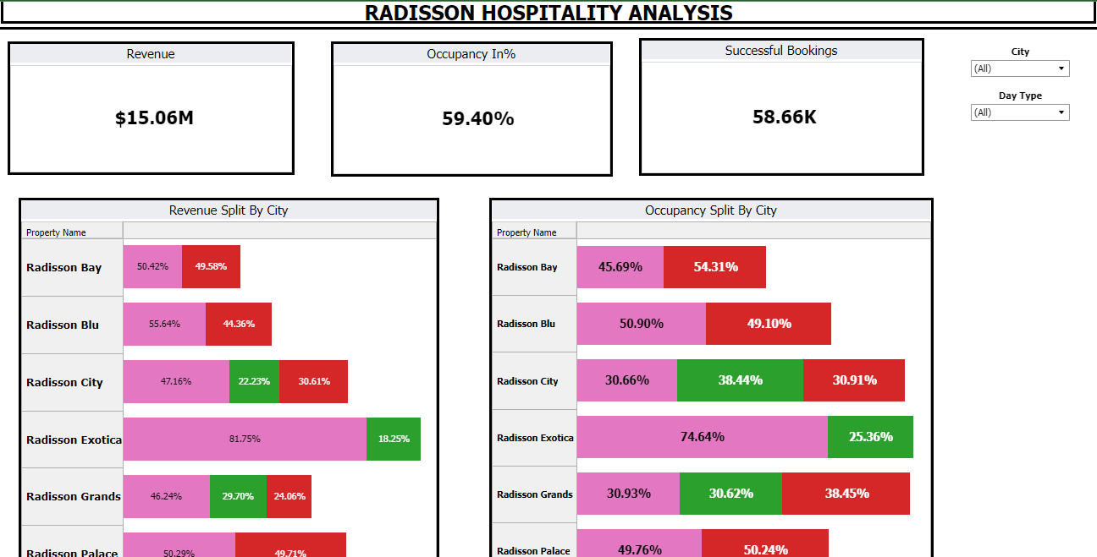

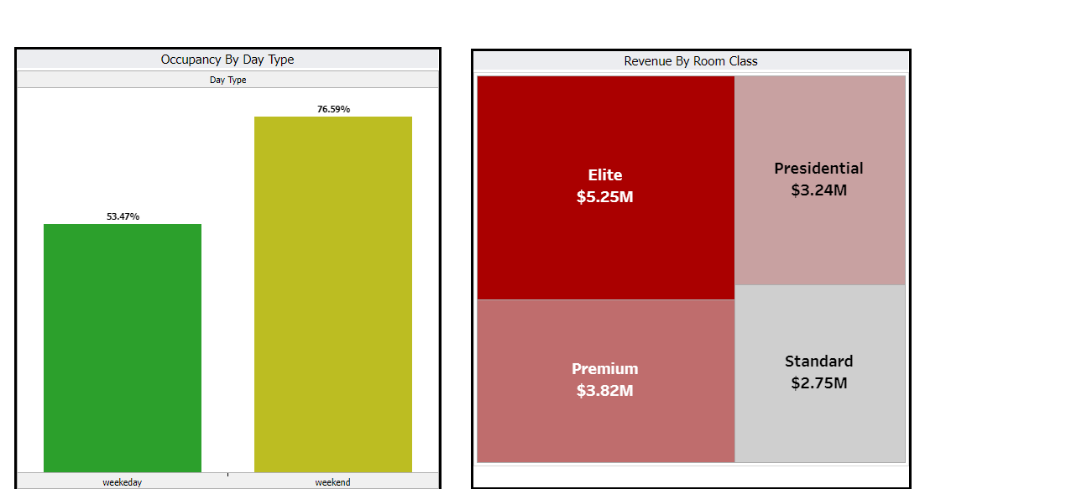

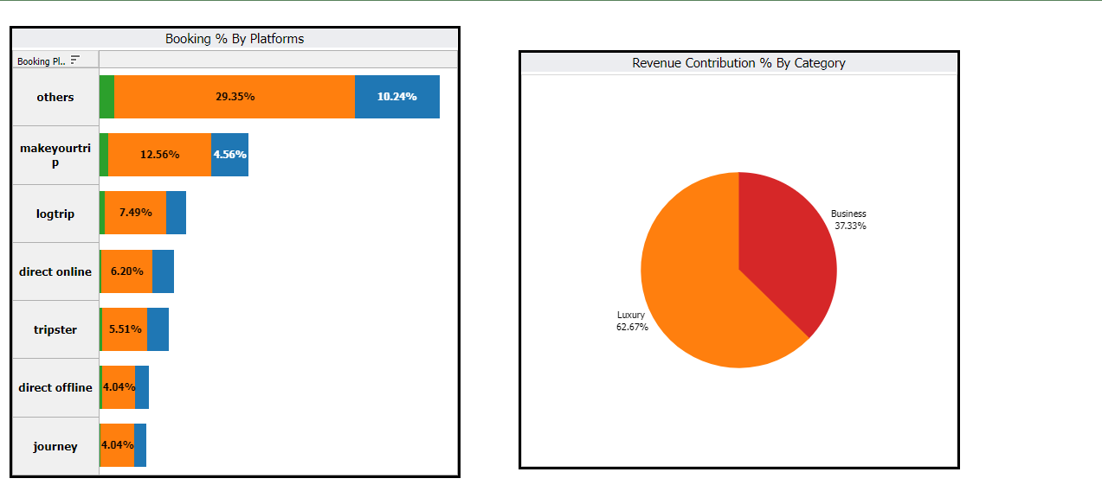

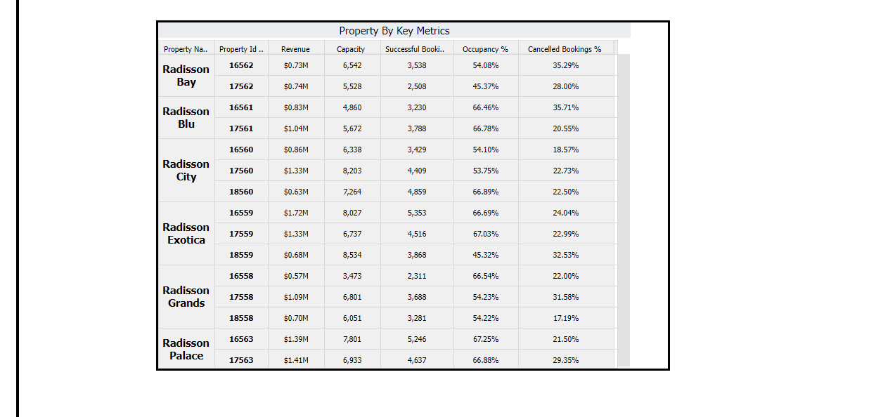

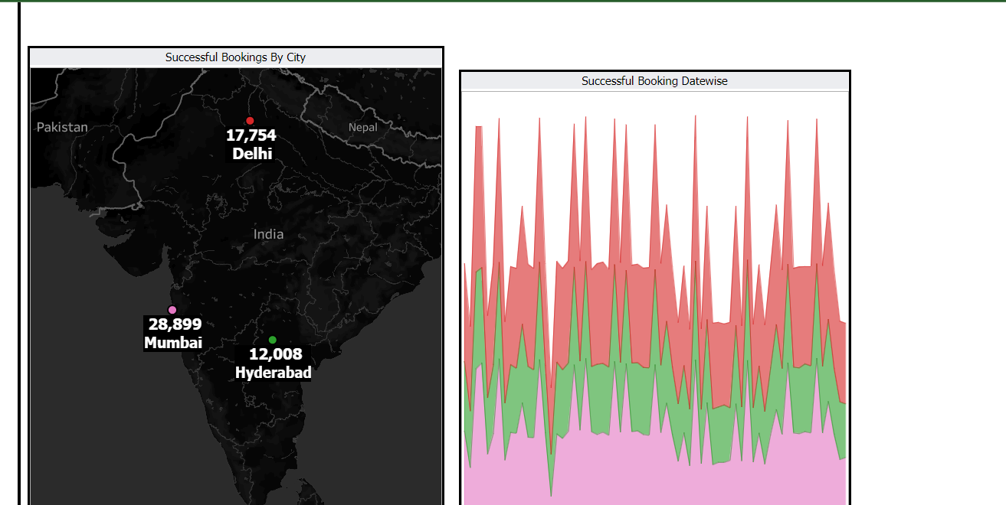

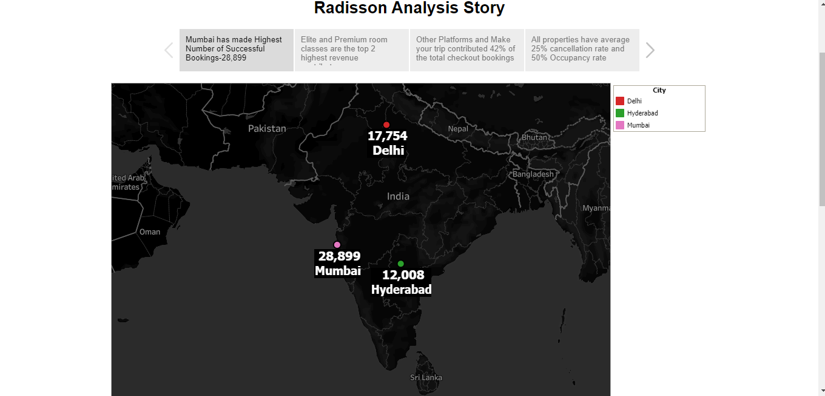

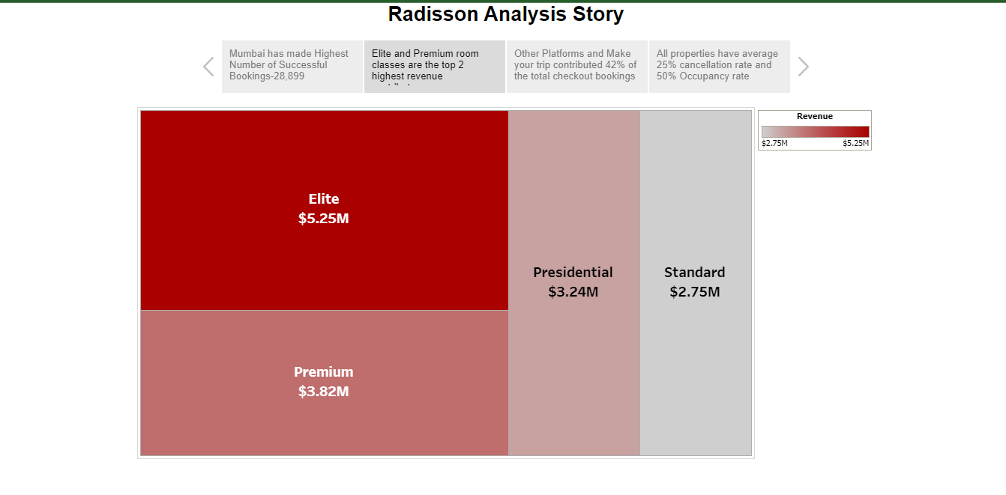

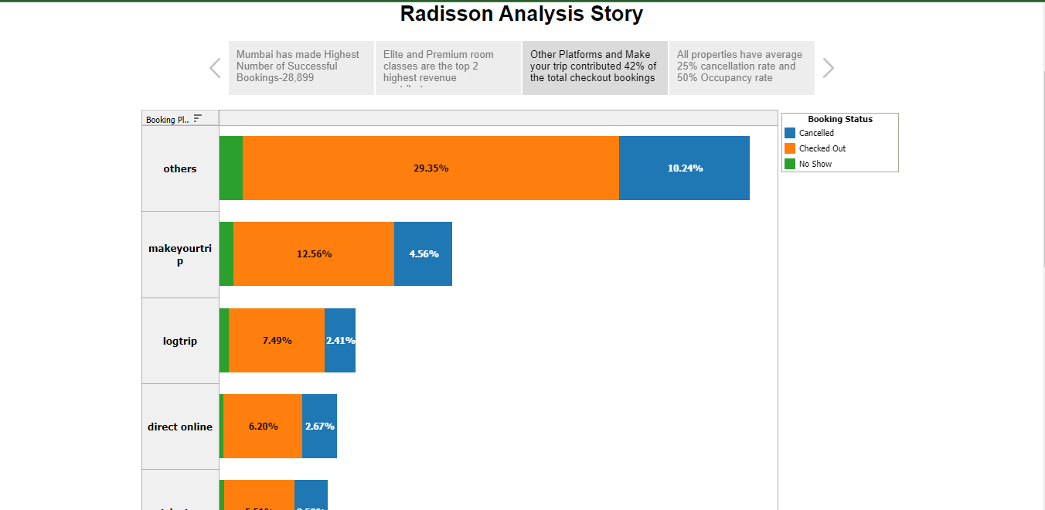

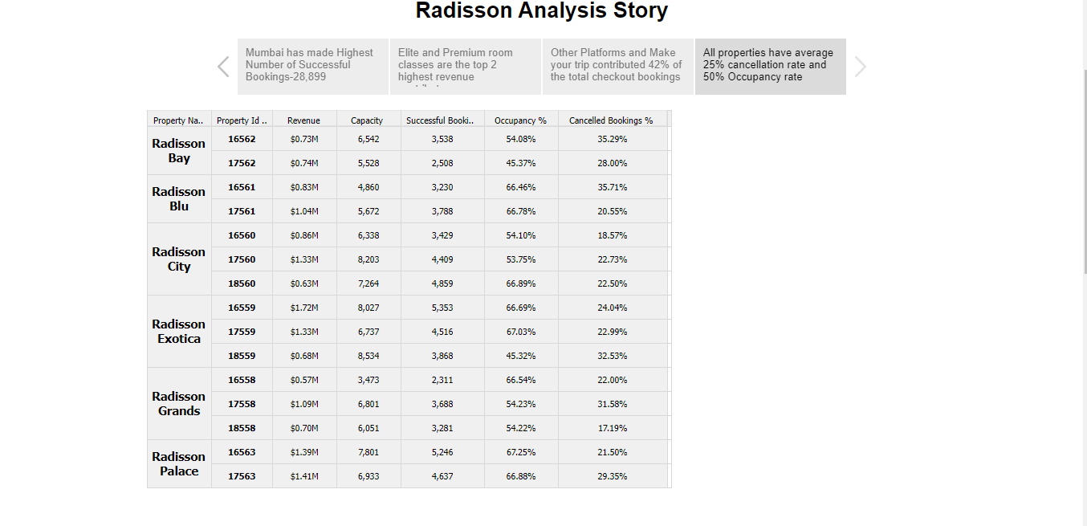

ADVANTAGES & DISADVANTAGES

The advantage is It provides all the comforts, security, and entertainment you need when not exploring the attractions surrounding you.

The disadvantage is If you are staying in a hotel room for a long time, it can start to feel a bit claustrophobic. You might want to consider renting an apartment or a house if you are planning to stay in one place for more than a week.

APPLICATIONS

Radisson owns multiple five-star hotels across India. They have been in the hospitality industry for the past 100 years. Due to strategic moves from other competitors and ineffective decision-making in management, Radisson is losing its market share and revenue in the luxury/business hotels category

CONCLUSION

The Managing director of Radisson wanted to incorporate Business and Data Intelligence in order to region their market share and revenue.

FUTURE SCOPE

To be the first choice in the mind of guests, owners and talent.

APPENDIXhttps://drive.google.com/file/d/17VtS4ZeImlqs2b4Fjcnk1SFGVUbdUrfw/view?usp=share_link